**Online Music Streaming Server**

**Ruchita Pame, Shruti Pingale, Prof. Mrunalini Bhandarkar,Prof. Isha Vyas**

Department of Electronics and Telecommunications, Pimpri Chinchwad College of Engineering, Pune-411044.

[shruti.pingale20@pccoepune.org](mailto:shruti.pingale20@pccoepune.org) ,

[ruchita.pame20@pccoepune.org](mailto:ruchita.pame20@pccoepune.org)

**Abstract -** Most of the youth of today's generation is fascinated by music. Not only the youth but also the generation above fifty years is also attached to music. Listening to music can reduce anxiety and pain as well as improve sleep quality and mental health. This Online Music Streamer Server which is a music website helps to design the appearances and also some of the basic functionalities of a popular music-streaming platform. This paper discusses the Online Music Streamer Server with the possibility of demonstrating this technology with applications

**Key Words:** Home page, About, Play, and Pause

**INTRODUCTION-**

Online Music Streamer Server is designed for use in the entertainment sector. This website consists of mainly three languages. The main motto of this project is to build a website that mimics the appearances with some of the basic functionalities of an Online music-streaming platform. Online music streaming service provides a platform that offers one of the best solutions for connecting with worldwide customers and provides them with a relaxing music platform. Online music streamer server which is available on many websites provides several pieces of music. In the case of an online music streamer server, there is trying to make an exact copy of that which is known as a clone.

**Methodology -**

The Online-music streaming server website is created using HTML (Hyper Text Markup Language), JS(JavaScript), and CSS (Cascading Style Sheet) languages. It is Frontend Project.

The online-music streaming server contains three stages, First Stage is to Analyze which button is placed in which container where the songs will be there, etc., and the second stage of this project is designing the website with the help of HTML. HTML gives a basic skeleton structure of our website The next stage is styling the website with the help of CSS, By using CSS language we come up with a beautiful design for our website. CSS is the standard and preferred mechanism for formatting HTML pages.

In this Online-Music streaming server Navigation bar, Container, Audio Progress Bar(Bottom), Song list, header, Footer, and some social media handlers links are there.

So now the Third stage is developing JavaScript, so basically, JavaScript provides logic to our website i.e. Play the song, Pause the song, Go to the Home page, Go to the About page, Go to the social handlers website, etc. these functions are made with the help of JavaScript.

So, we can say JavaScript gives the project into existence.

a) Block Diagram:

Navigation Bar

No Copyright on the song Extracting in the container

Create Pause and Play Buttons using Styling

Song list (Music libraries)

Audio Progress Bar (Bottom)

Play and End

b) Flowchart:

Navigation Bar

About

Home

Display song list

Information

Touch & Display

Pause & go to Audio Progress Bar

So as we can see in the above block diagram and flowchart on the top of the website navigation bar is there. The navigation bar contains Home and About features.

By clicking on the Home button you can visit the home page of the website. About will give the information of our online music-streaming server.

There is one container that contains the song on the list. By clicking the play and pause buttons we can change the song and play or pause the song. Also with the help of the audio progress bar, we can play, pause and change the song. In the right corner of the website, you can see the duration of the song. In the footer, there is some information about social handlers, etc. This is all about our online music streaming platform

**Result:**

In this paper clone of Spotify is developed. An offline server is used to process the clone in real time. Spotify clone offers users a comprehensive music streaming platform through a desktop and the web.

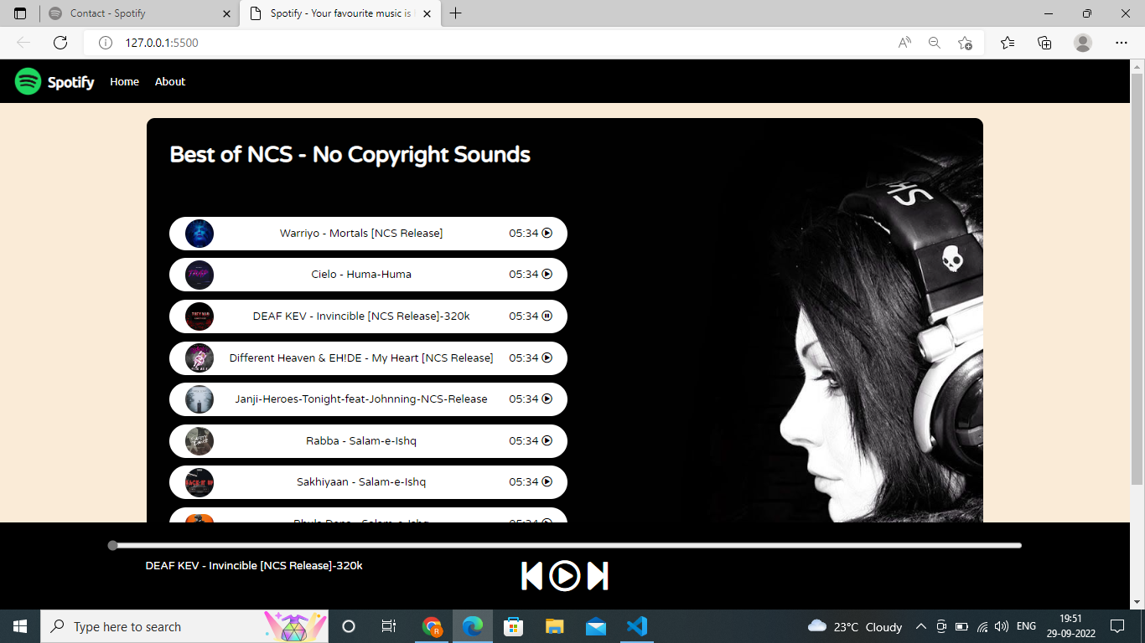

Fig (d)

Fig d is the final outlook of the Spotify clone. Actual music streaming platform is limited to the apps and requires users to run such an app. Spotify Clone will offer an offline music platform. Several other music streaming services offer more possibilities in incorporating music playback in new environments, but, like Spotify, these all require a user to be logged in to the service. As a web technology, Spotify opens up no core functionalities to developers, nonetheless, it does offer metadata of its music library and easy linking to in-app functionalities. The Spotify clone can be used by all groups of generations as it is easy to use.

Spotify clones can be used in any event or any function for fun purposes with an available music library.

**Conclusion:**

The study concluded that consumer preferences are influenced by service quality, and ease of use. Most people will prefer our service because of the affordability factor i.e. usability, service, etc., and consumers will be satisfied with the services provided by this online music streamer.

**Future scope:**

Backend development using node JS can be added for music suggestions according to the user's test of music. Copyrighted songs can be added to avoid any disappointment from a user. Users should establish their playlists so that can able to add their favorite songs and they can share them with their friends.

**References:**

[1]Sam Verkoelen, Donna Piët ,Jules Verdijk,Web Technology: Spotify,Media Technology Leiden University.Volume 10 Issue II Feb 2022

[2] Debra Howcroft University of Salford John Carroll University of Salford, A Proposed Methodology for Web Development, Volume: 05, Number: 5, September 2015.

[3] Alok Ranjan, Abilasha Sinha, An Analysis of HTML and CSS Syntax Errors in a Web Development Course, Vol. 8 Issue 9, September -2018